

STUDENT NAME: MICHAEL ASILWA
ADMISSION NUMBER: BSCCS/2024/56330
COURSE: COMPUTER SCIENCE
UNIT CODE: BIT4139
UNIT NAME: ETHICAL HACKING AND COUNTER MEASURES
LECTURER NAME: MICHAEL NYORO
ACADEMIC YEAR: YEAR 3 SEMESTER 2

Contents
WEEK ONE 2
INTRODUCTION TO ETHICAL HACKING 2
Fig1.1: kali Linux running on oracle virtual box 2
WEEK 2 2
VULNERABILITY SCAN 2
Fig1.2: vulnerability scan on ip>192.168.56.102 2
Students reflection 3
WEEK 3 3
FOOTPRINTING AND RECONNAISSANCE 3
Fig1.3: DNS foot printing done on Microsoft.com using recon-ng>returned hosts 3
Fig 1.4: social engineering foot printing done on Microsoft.com >returned contacts 4
Students’ reflection 4
WEEK 4 4
NETWORK SCANNING 4
Fig1.5: open port scanning on metasploitable 4
Fig1.6: banner grabbing done on metasploitable using Nmap on kali 5
SAMPLE TASK ONE 5
Fig 1:whois operation on linkedin.com 5
FIG 2: linkedin.com organization details 6
Fig 3: service running on linkedin.com 6
Fig 4: leaked credentials 7
SAMPLE TASK 2 7
Fig 1: port scanning by nmap 8
Fig 2: os detection using nmap 8
Fig 3: nikto vulnerability scan 8
Vulnerability Summary 9
Students reflection 9

WEEK ONE

INTRODUCTION TO ETHICAL HACKING
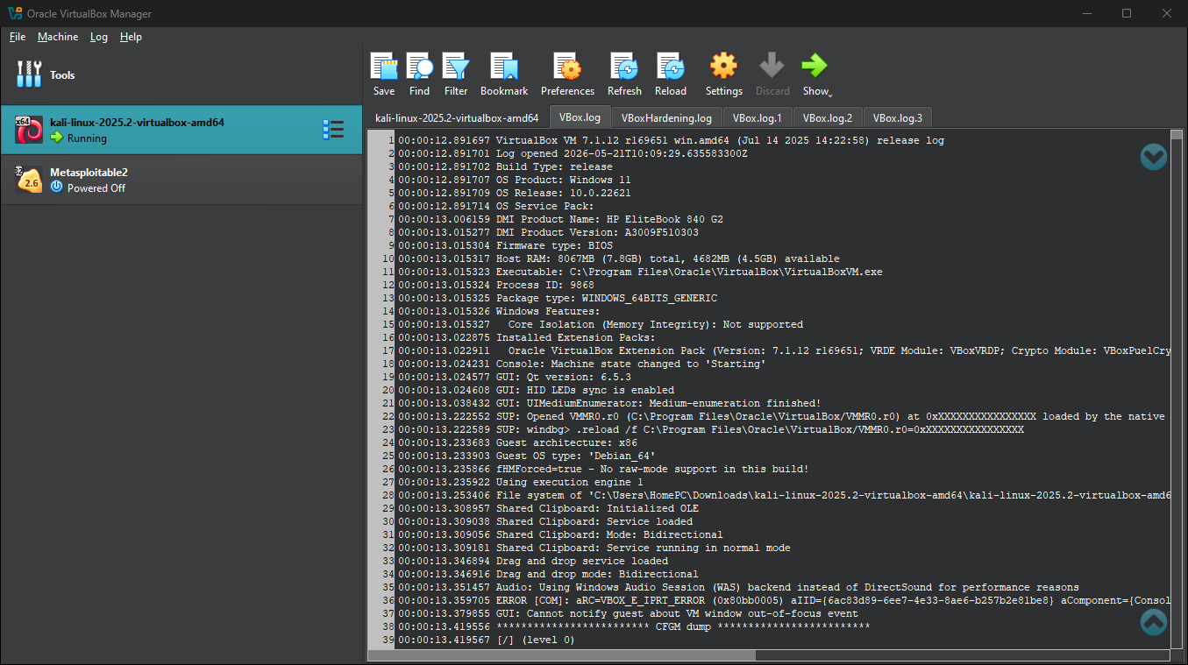

Fig1.1: kali Linux running on oracle virtual box

WEEK 2

VULNERABILITY SCAN
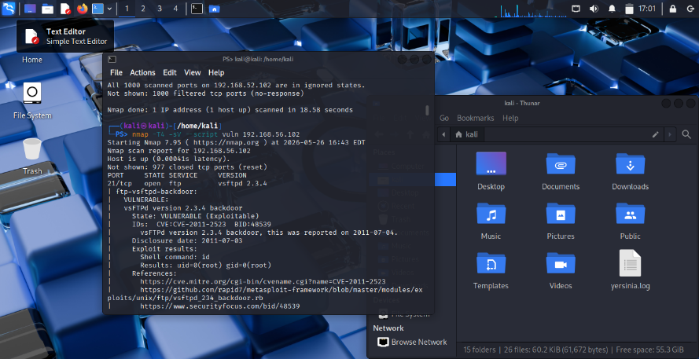

Fig1.2: vulnerability scan on ip>192.168.56.102

Students reflection
Scanning on metasploitable helped me to understand vulnerability scanning is used to identify weakness in a system before they can be exploited by attackers

WEEK 3

FOOTPRINTING AND RECONNAISSANCE
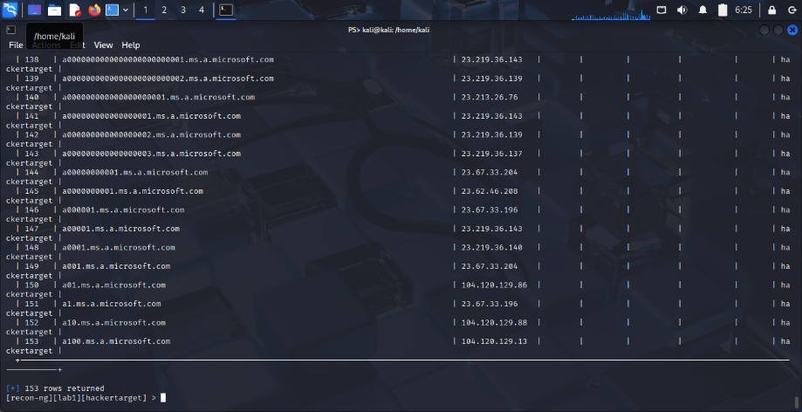

Fig1.3: DNS foot printing done on Microsoft.com using recon-ng>returned hosts

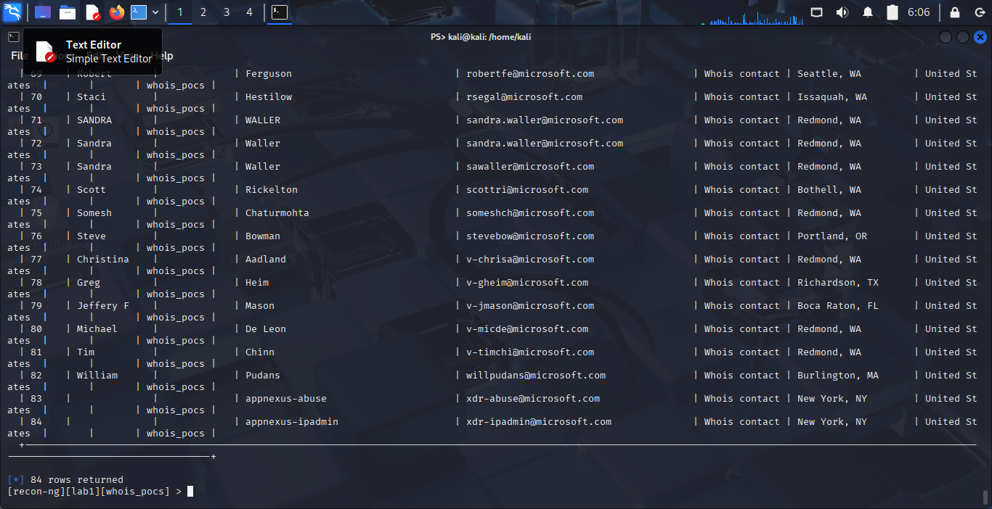

Fig 1.4: social engineering foot printing done on Microsoft.com >returned contacts

Students’ reflection
I learned how footprinting is used to gather information about a target system or organisation
This activity helped me understand how information can be obtained from open sources without directly interacting with the system done by recon-ng

WEEK 4

NETWORK SCANNING
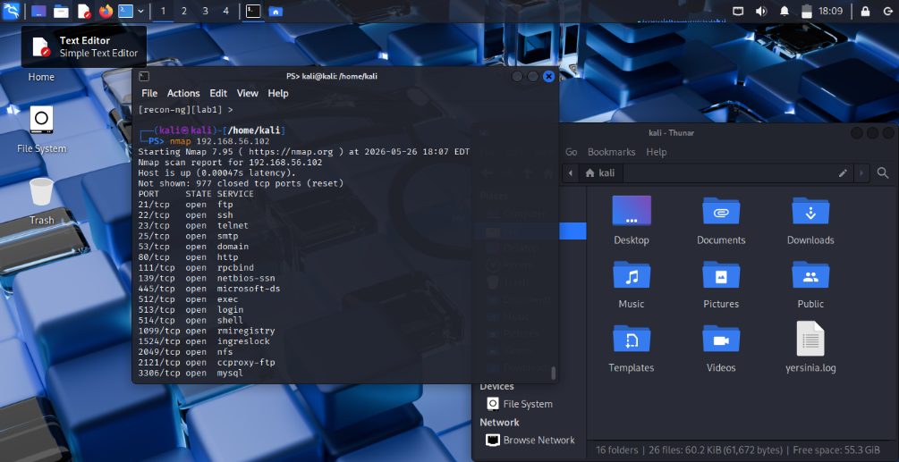

Fig1.5: open port scanning on metasploitable

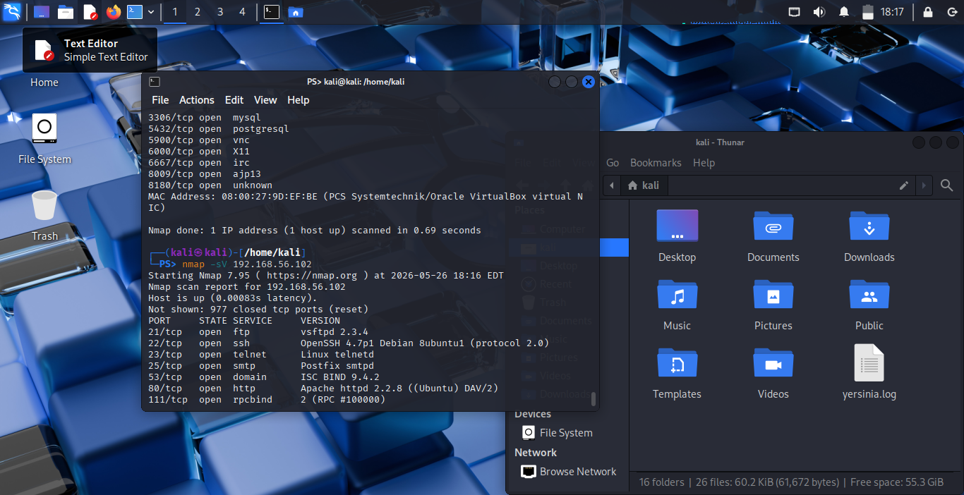

Fig1.6: banner grabbing done on metasploitable using Nmap on kali

SAMPLE TASK ONE
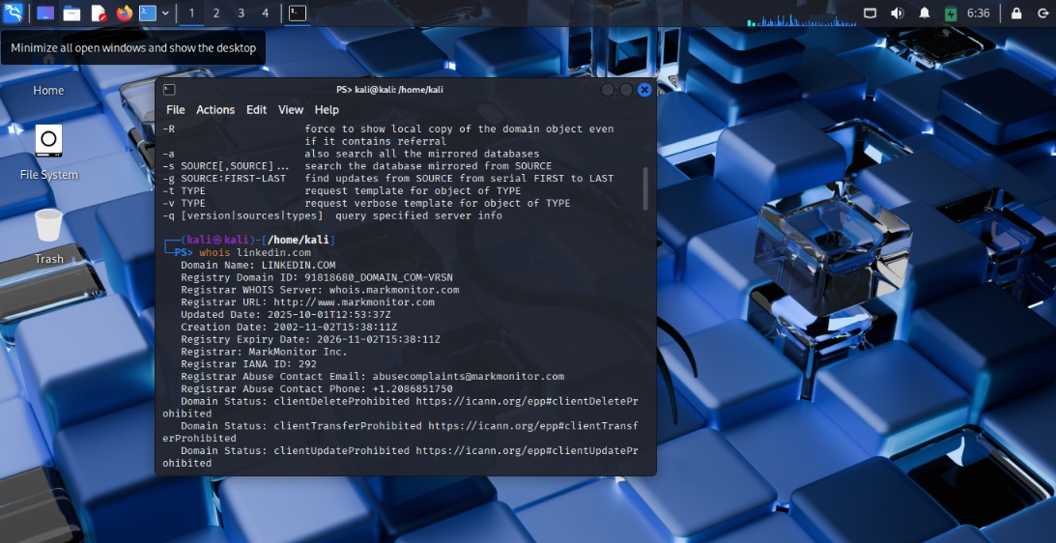

Fig 1:whois operation on linkedin.com

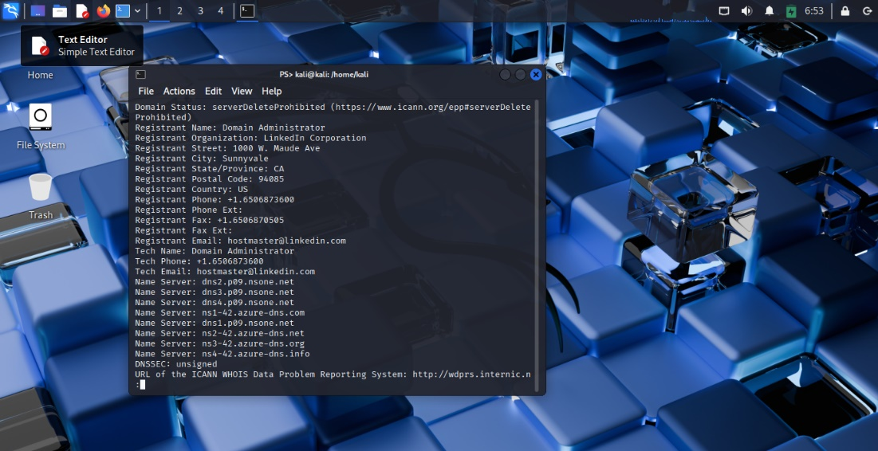

FIG 2: linkedin.com organization details

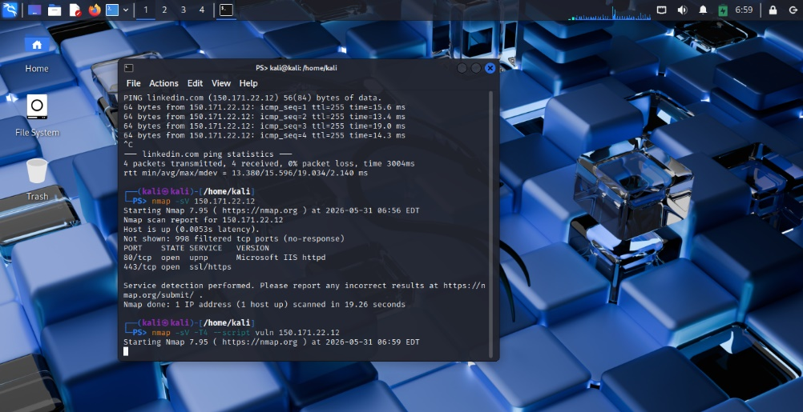

Fig 3: service running on linkedin.com
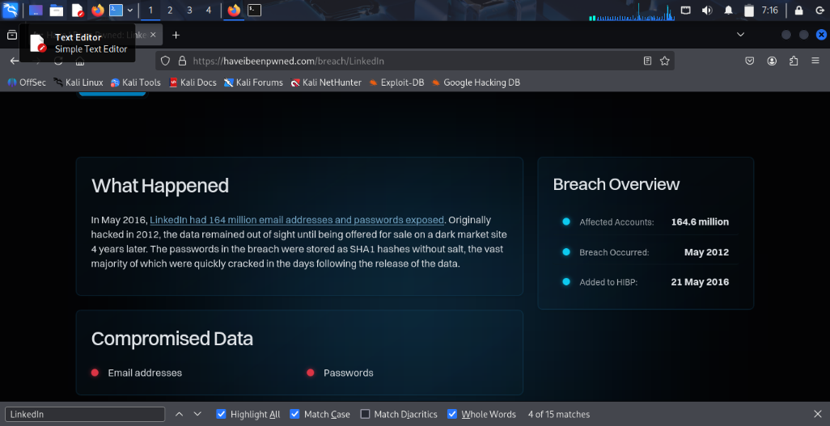

Fig 4: leaked credentials
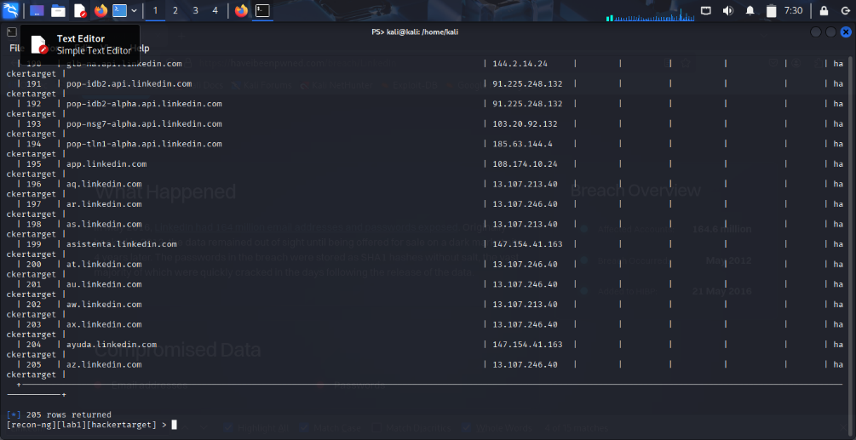
Fig 5: linkedin subdomains
Students reflection
Using WHOIS was essential in knowing the information the domain holds like; who owns it, when it was created e.t.c.
Finding subdomains and leaked credentials

SAMPLE TASK 2
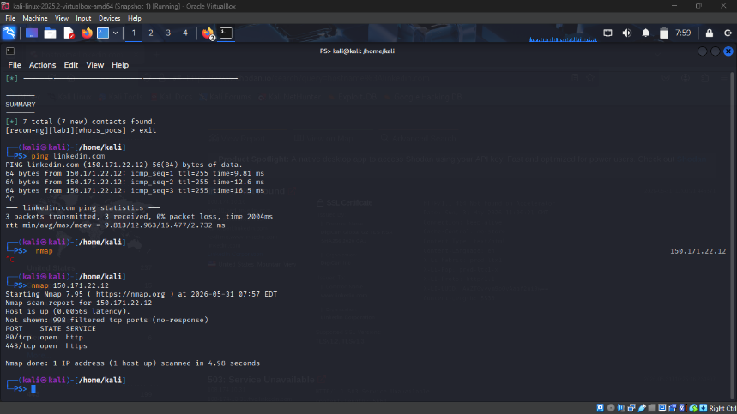

Fig 1: port scanning by nmap
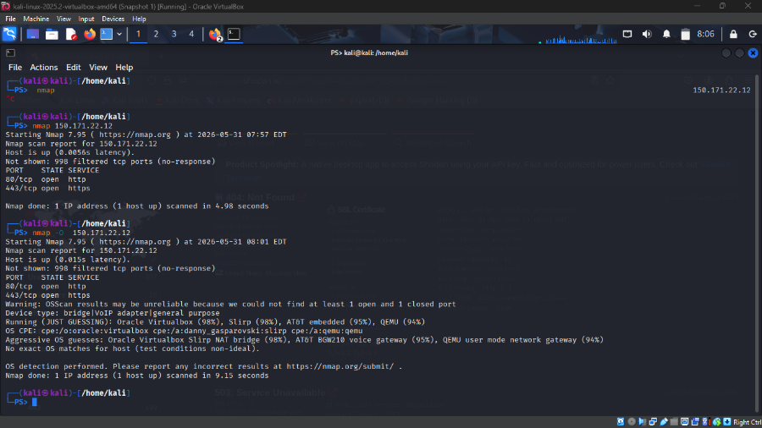

Fig 2: os detection using nmap
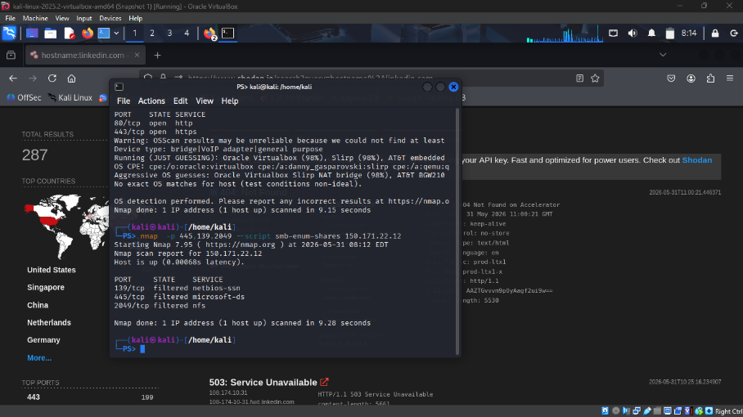
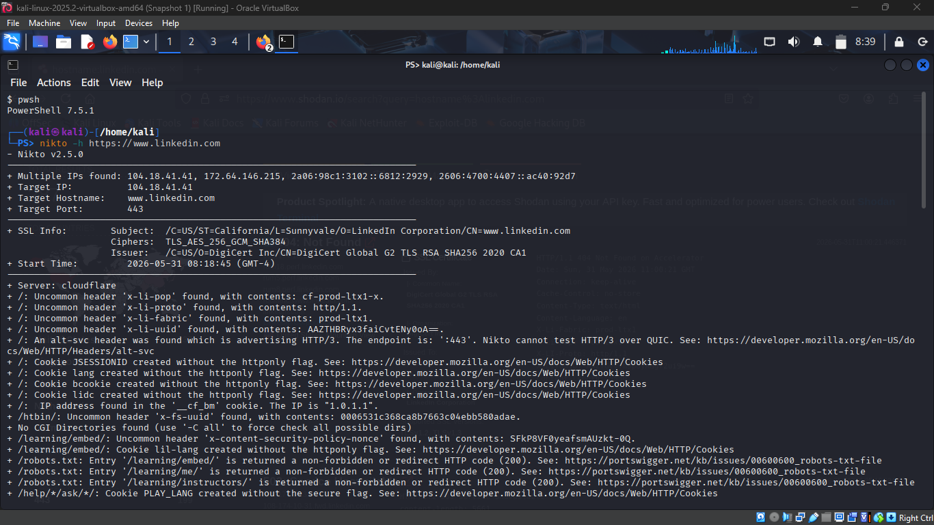

Fig 3: nikto vulnerability scan

Vulnerability Summary
# | Vulnerability | Severity | Tool Used
1 | Cookies without HTTPOnly and Secure flags | Medium | Nikto
2 | Internal infrastructure headers exposed | Medium | Nikto / Shodan
3 | BREACH attack vulnerability | High | Nikto
4 | robots.txt exposes sensitive directories | Low | Nikto
5 | Drupal CMS detected on jobs section | Low | Nikto
6 | 205 subdomains — large attack surface | Medium | Recon-ng
7 | OS fingerprinting partially possible | Low | p0f / Nmap
8 | 2012 SHA1 breach — credentials in circulation | Critical | HaveIBeenPwned
9 | Application version number exposed in headers | Low | Nikto

Students reflection
In this I used nikto to perform vulnerability scan on a web server helping in identifying potential security issues such as insecure configurations and breach attack vulnerability
Learnt how to interpret the scan results and asses the security risks associated with the discovered vulnerabilities

